**A Research Paper on**

**DIGITAL LOGICS**



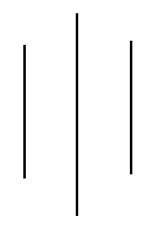

**Submitted By:**

Binita Luitel

Symbol No: 76214005

T.U Reg No: 9-2-214-38-2019

**Submitted To:**

Mr. Biraj Subedi

Lecturer

Sukuna Multiple Campus

Sundarharaincha, Morang

In partial fulfillment of the requirement for the course BICTE semester

August 24, 2021

**PREFACE AND ACKNOWEDGEMWNT**

Digital logic is concerned with the interconnection among digital components and is a term used to denote the design and analysis of digital systems. This report presents half of the basic concept used in the design of digital system. It contains electronic gates basic unit of digital circuit, introduction about digital and analog devices and their working principles. It describes the basic concept of combinational circuit through multiplexer and DE multiplexer. It also presents a brief introduction of VHDL a hardware descriptive language used to design and develop integrated circuit. This report also contains application of registers, parallel adder, and seven segment display. These are basic units used in digital circuit development.

I would like to express my sincere gratitude to my friends Mr. Sanam Tamang, Mrs. Sudiksha Basnet and Mrs. Paru Rai who helped me to make this report. I am grateful to Mr. BIRAJ SUBEDI ( lecture of Sukuna multiple campus ) to give us the opportunity to make report on this topics and for guidance.

**Table of Content**

1. Electronic Gates………………………………………………………………1
2. Digital and Analog Devices……………………………………………...6
3. Multiplexer and De-multiplexer……………………….……………..8
4. Brief Introduction of VHDL……………………………………….…….10
5. Application of Register……………………………….……………….….11
6. Parallel Adder…………………………..…………………………………...12
7. Seven Segment Display……………………………………………………13

**ELECTRONIC GATES**

* Electronic gates are used to make electronic digital circuits also called logical circuit.
* Any desired information can be operated upon by passing binary signals through various combination of logic circuits.
* Each signal represents a variable and carry one bit information .
* There are three types of basic gates they are AND, NOR and NOT
* Two universal gates NAND and NOR
* Two exclusive gates XOR and XNOR

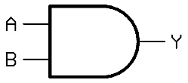**AND gate** : It produces high output when both inputs are high otherwise it produces low output.

Symbol



Boolean algebra y= AB

Truth table OF AND GATE

|  |  |
| --- | --- |
| Inputs | Outputs |
| A B | Y |
| 0 0 | 0 |
| 0 1 | 0 |
| 1 0 | 0 |
| 1 1 | 1 |

**OR GATE :** It produces low output when both inputs are low otherwis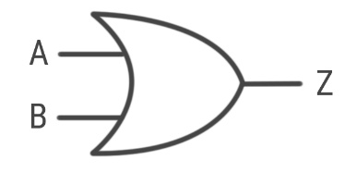e it produces high **output.**

Symbol

Boolean Algebra = A+B

|  |  |
| --- | --- |
| Inputs | Outputs |
| A B | Z |
| 0 0 | 0 |
| 0 1 | 1 |
| 1 0 | 1 |
| 1 1 | 1 |

Truth table of OR GATE

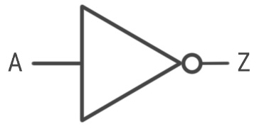**NOT gate :** It is the complement of inputs it produces high output when input is low and vice versa.

**Symbol**



**BOOLEAN ALGEBRA : A**

TRUTH TABLE OF NOT GATE IS presented BELOW :

|  |  |
| --- | --- |
| INPUTS | OUTPUTS |
| A | Z |
| 0 | 1 |
| 1 | 0 |

**Universal gate : NAND gate and NOR gate are known as universal gate. Because they can be combined to produce any of the other gates like OR, AND, and NOT gates.**

**NAND gate :** It gives low output when all inputs are high otherwise it produces high output.

Symbol is given below ;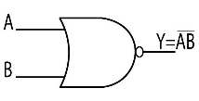



Boolean algebra = AB

Truth table For NAND GATE

|  |  |  |
| --- | --- | --- |
| Inputs |  | Outputs |
| A B | AB | AB |
| 0 0 | 0 | 1 |
| 0 1 | 0 | 1 |
| 1 0 | 0 | 1 |
| 1 1 | 1 | O |

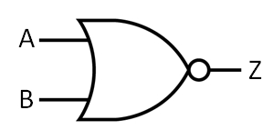**NOR gate :** It gives high output only when both inputs are low otherwise it produces low output.

**Symbol**



**Boolean Algebra = A+B**

Truth table FOR NOR GATE

|  |  |  |
| --- | --- | --- |
| Inputs | A+B | OUTPUTS |
| A B |  | Z |
| 0 0 | 0 | 1 |
| 0 1 | 1 | 0 |
| 1 0 | 1 | 0 |
| 1 1 | 1 | 0 |

**EXCLUSIVE GATES : XOR and XNOR are called exclusive gates.**

**XOR gate :** It gives low output when all inputs are same otherwise it produces high output.

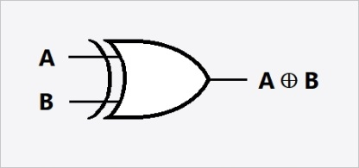Symbol of XOR gate

Truth Table For XOR gate

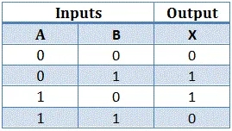

**XNOR gate :** It gives high output when inputs are same otherwise output is low .

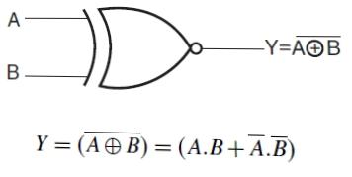

Symbol of XNOR gate

Truth table for XNOR gate is as follow :

|  |  |  |  |
| --- | --- | --- | --- |
| Inputs |  |  | Outputs |
| A B | A B | A B AB | A B + A B |
| 0 0 | 1 1 | 10 | 1 |
| 0 1 | 1 0 | 0 0 | 0 |
| 1 0 | 0 1 | 0 0 | 0 |
| 1 1 | 0 0 | 0 1 | 1 |
|  |  |  |  |

**DIGITAL AND ANALOG DEVICES**

The term digital and analogue is used to describe two different system used in information technology. Analog technology is a system where information is translated into electric pulses of varying amplitude. In digital system transformation of information is into binary format that is 0 and 1 where 0 represents off state and 1 represents on state.

The devices which are designed from analogue technology are analogue devices and those devices which can process digital signals, information are digital devices.

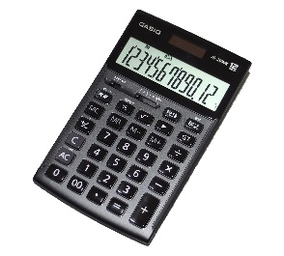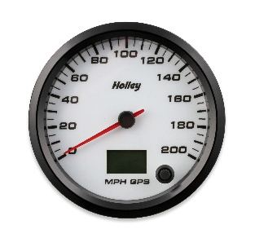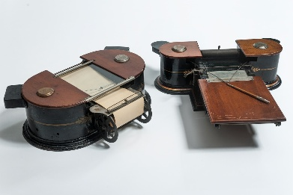ANALOG DEVICE: Uses continuous signal with varying magnitude. It uses sine waves. It records the physical wave forms as they are originally generated. Data is stored in form of waveform signals. They are a combination of both analog machine and analog media that can together measures and records, reproduces continuous information.

DIGITAL DEVICE : It processes electrical signals that represent either one (high) or zero (low) states. The high state is represented by the presence of electric plus and low state is represented by the absence of electric signals. Each one or zero is refered as a bit eight bit is called one byte. Modern pc can process 64 bit of data at a time. It forms square waves desktop computers, pc, mobile phones, storage devices hard disk, flash drives, input devices such as keyboard, scanner, output devices such as printer and speaker etc are digital devices.





**MULTIPLEXER AND DEMULTIPLEXER**

Multiplexer and DE multiplexer are combinational logic circuit which output is depend only on the present input but not on passed input or outputs. Therefore MUX and DEMUX don’t need any memory.

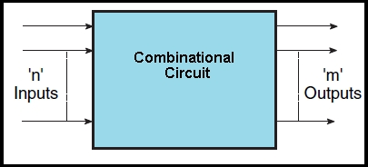 Diagram of combinational circuit is as follow

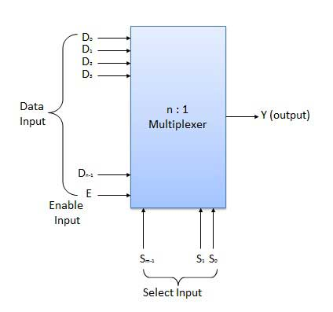**MULTIPLEXER:** It is a combinational circuit which selects binary information from one of many input lines and converts it into a single output line. The selection of a particular input line is controlled by a set of selection line. For n inputs there are m selection line and one output where 2^m = n

Block diagram of MULTIPLEXER

# **DEMULTIPLEXER**:

* It receives information on a signal input and transmits into one of the possible output lines.
* The selection of output lines is controlled by selection lines.
* For n output there is m selection line for a single input line where n = 2^m
* DEMUX are used in paraller converter, in ALU and in commination system .
* It does reverse of multiplexer.

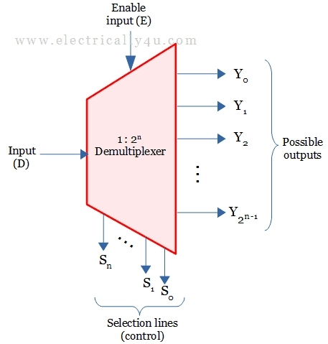

Block diagram of DE multiplexer

**BRIEF INTRODUCTION OF VHDL**

VHDL is VHSIC Hardware Description Language. Where VHSIC means Very High Speed Integrated Circuit. So VHDL is hardware description language which describes the behaviour or structure of a digital system which is used to develop very high speed integrated circuit. HDL enables a precise formed description of an electronic circuit that allows for automated analysis and simulation of an electronic circuit. It is a textual description consisting of expression statements and control structure. VHDLs form an integral part of electronic design automation.

VHDL is a generally used to write text models which describe a logic circuit. Such a model is processed by a synthesis program. And a simulation program is used to test the logic design.

**APPLICATION OF REGISTER**

A register is a group of binary storage cell suitable for holding binary information. It consists of a group of flip flops and gates. The flip-flops hold binary information and gates control when and how new information is transferred into the register. An n bits register consists of n flip flops and is capable of storing n bits binary information.

The register in digital system can be classified as either operational or storage. An operational register is capable of storing binary information in its flip flop and also has combinational gates capable of data processing task. A storage register is used solely for temporary storage of binary information.

**Application of register can be describe in following points.**

1. Registers are used in memory such as ROM, Chips, Flash memory, cache memory in CPU is also made by registers.
2. Register are also used for temporary data storage.
3. Registers are used in sequential circuit such as counters which are used in digital clock and frequency counter.
4. Register are used in serial transformation of binary information where the information are transferred one bit at a time .
5. Shift register is used as parallel to serial converter which convert parallel data into serial data. And it is used in Analog to digital convertor.
6. Shift register is also used as serial to parallel convertor which converts the serial data into parallel and used in digital to analog conversion.
7. Shift registers are also used for data transfer and manipulation.
8. The serial in serial out and parallel in parallel out shift registers are used to produce time delay on digital circuit.

**PARALLEL ADDER**

A parallel adder is a digital circuit capable of finding the arithmetic sum of two binary numbers that is greater then one bit in length by operating pair of bit in parallel.

It consists of full adder connected in a chain where the output carry from each full adder is connected to carry input of the next high order full adder in the chain.

An n bit parallel adder requires n full adder to perform the operation. Parallel adders normally incorporate carry look a head logic to insure that carry propagation between subsequent stages of addition doesn’t limit addition speed.

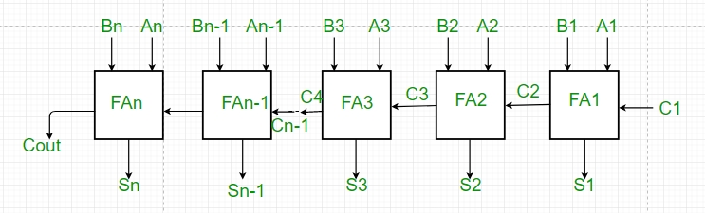

Fig : parallel adder

As shown in figure the firstly full adder FA1 adds A1 and B1 along with carry C1 to produce sum S1 and C2 is connected to the next adder. This process continue till the last full adder FA n uses carry C n-1 to add with it inputs A n and B n to generate the last bit of the output along last carry bit C out.

**SEVEN SEGMENT DISPLAY**

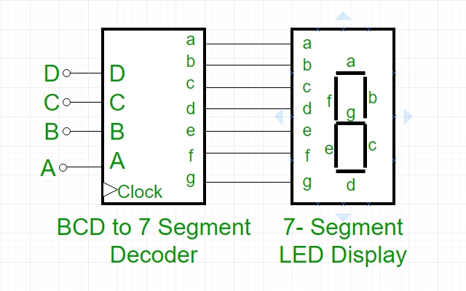Seven segment display is an electronic device which consists of Seven LEDs ( light emitting diodes) arranged in some definite pattern which number is used to display hexadecimal numbers. It doesn’t work by direct supply of voltage to different segment lEDs. Frist decimal number is changed into its BCD equivalent signal then BCD to seven segment decoder converts that signal. It has four input lines (A, B, C and D ) seven output lines (a, b, c, d, e, f, g)

Truth table for BCD TO seven segment display 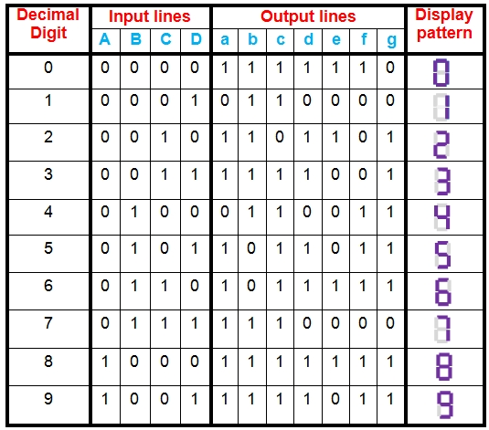

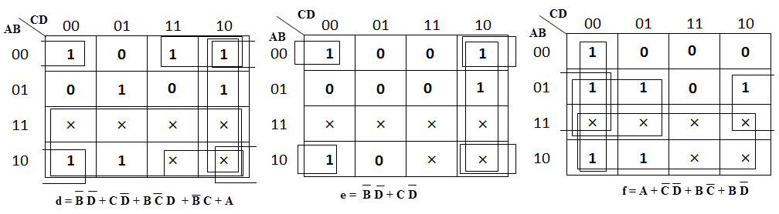K MAP SIMPLIFICATION OF SEVEN OUTPUT IS :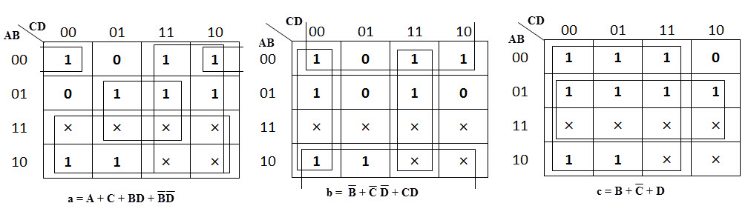

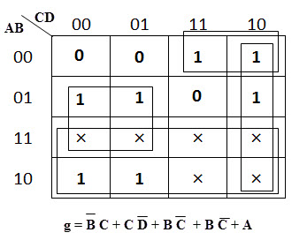

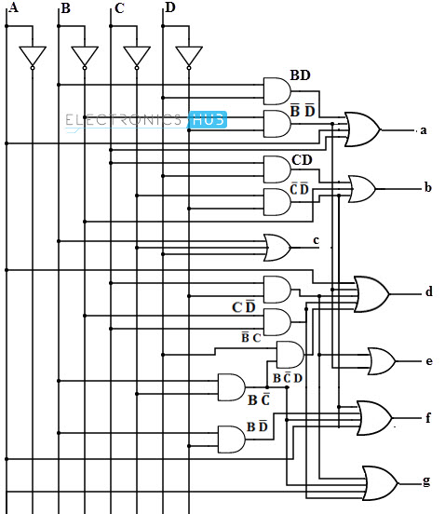**Applications –**  
Seven-segment displays are used to display the digits in calculators, clocks, various measuring instruments, digital watches and digital counters.

The circuit diagram of BCD seven segment decoder is as follow.